Centre for Development of Advanced Computing

*Pune, Maharashtra*

### ****TITLE****

**Build a two node Disk-less HPC-cluster using OpenHPC with Warewulf, Slurm, Nagios, and Ganglia and do a HPL benchmarking**

Submitted by:

RAJA KANWAR 220940127051

PRAJYOT BADANGE 220940127049

RAHUL KAMBLE 220940127050

PRAVIN SAWARGAONKAR 220940127052

RUCHIRA WARTHI 220940127053

Requirements

The master node serves as the overall system management server (SMS) and is provisioned with CentOS7.7 and is subsequently configured to provision the remaining compute nodes with Warewulf in a stateless configuration.

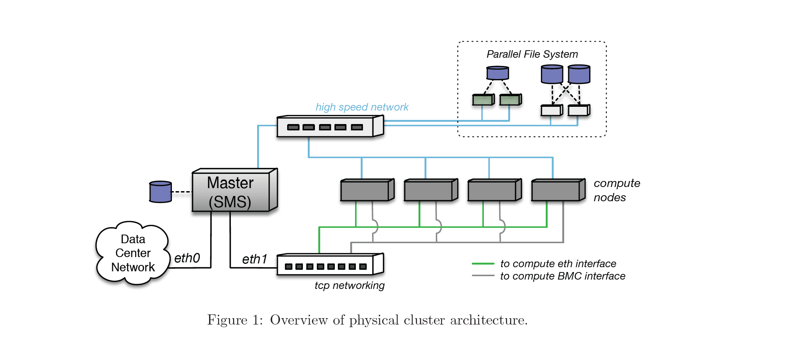 For file systems, the master server will host an NFS file system that is made available to the compute nodes.

# VMware Require :

* One Master Vm with Two Network Adapters
  + ens33 (NAT)
  + ens34 (Host-only)
* Processor : 4
* Ram : 8 GB
* Storage : 100 GB

CONTANT



**Warewulf** - Operating System provisioning platform for Linux



**Slurm** - Open-Source Workload Manager/Scheduler



**Nagios** - Open Source Infrastructure Monitoring Package



**Ganglia** - Scalable Distributed System Monitoring Tool

**HPL-Benchmark** - High-Performance Linpack benchmark implementation

***INSTALLATION***

Pre-requisite:

We have to stop and disable firewall and disable selinux

* systemctl stop firewalld
* systemctl disable firewalld
* vi /etc/selinnux/conf

# sethostname of machine as master

* hostnamectl set-hostname master

#Check for the file of ens36

(if not there use #nmtui command and edit Wired Connection 1 to ens36)

* cat /etc/sysconfig/network-scripts/ifcfg-ens36
* ifconfig ens34

Output -> ens34:192.168.150.128

* vi /etc/hosts

-> edit ->192.168.149.147 master

* yum -y install yum-utils

***Install OpenHPC Components***

* yum install http://build.openhpc.community/OpenHPC:/1.3/CentOS\_7/x86\_64/ohpc-release-1.3-1.el7.x86\_64.rpm
* yum repolist
* yum -y install ohpc-base
* yum -y install ohpc-warewulf
* yum -y install chrony
* vi /etc/chrony.conf
  + Edit this Conf. file -> server 192.168.149.147iburst
  + allow 192.168.149.0/24 (uncomment and edit network address)
  + local stratum 10 (uncomment)
  + SAVE and Exit
* systemctl start chronyd
* systemctl enable chronyd
* yum install ntpdate
* ntpdate -q 192.168.149.147
* vi /etc/warewulf/provision.conf

edit -> change network device = ens34

* grep device /etc/warewulf/provision.conf
* vi /etc/xinetd.d/tftp

edit -> disable = no

* grep disable /etc/xinetd.d/tftp

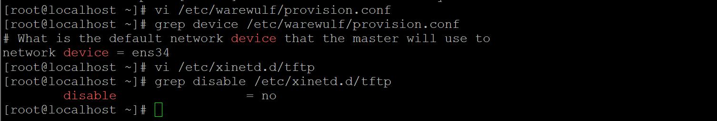

**Add Slurm services on master node**

* yum -y install ohpc-slurm-server
* yum -y install slurm-sview-ohpc slurm-torque-ohpc
* vi /etc/slurm/slurm.conf

edit -> ClusterName=pearl

* + ControlMachine=master
  + NodeName=c[1-2]
  + Nodes=c[1-2] --> This is my nodename
* grep NodeName= /etc/slurm/slurm.conf



* echo ens34
* ifconfig ens34
* systemctl restart xinetd
* systemctl enable mariadb.service
* systemctl restart mariadb
* systemctl enable httpd.service
* systemctl restart httpd
* systemctl enable dhcpd.service

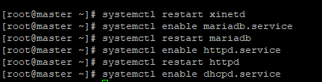

* echo ${CHROOT}
* export CHROOT=/opt/ohpc/admin/images/centos7.7
* echo ${CHROOT}

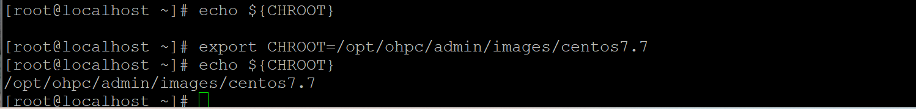

* wwmkchroot centos-7 $CHROOT -> Building initial BOS image
* uname -r
* chroot ${CHROOT} uname -r

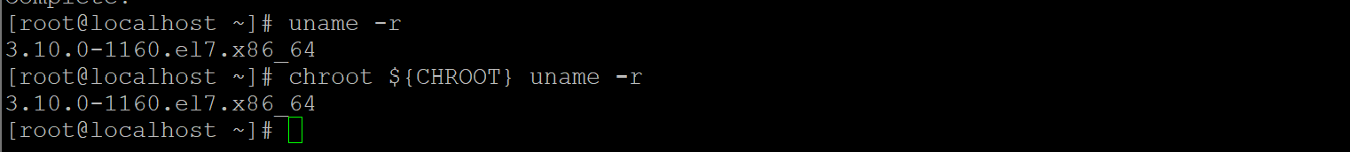

* yum -y --installroot=${CHROOT} update

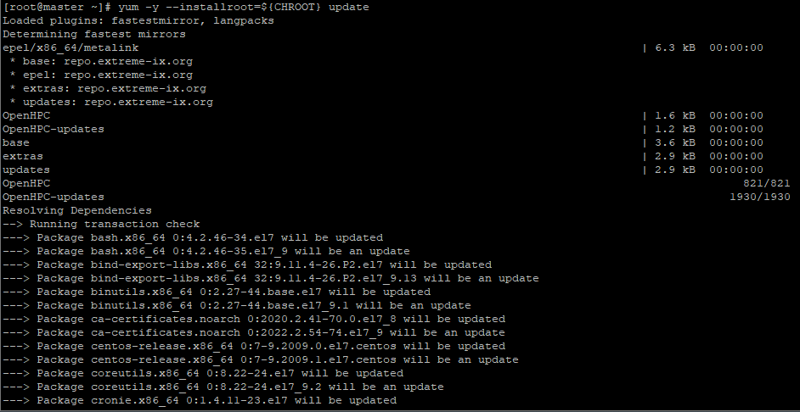

* yum -y --installroot=${CHROOT} install \

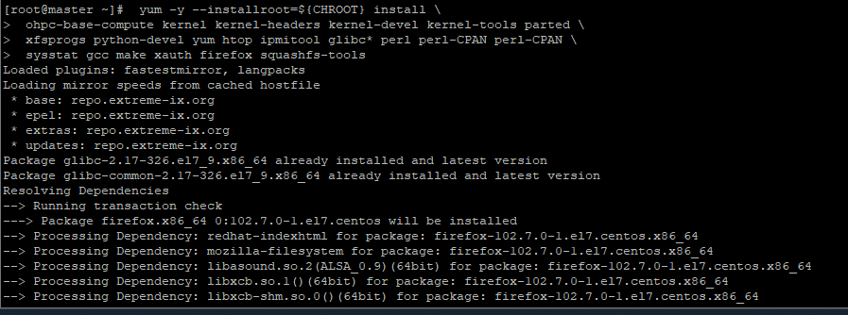

* ohpc-base-compute kernel kernel-headers kernel-devel kernel-tools parted \
* xfsprogs python-devel yum htop ipmitool glibc\* perl perl-CPAN perl-CPAN \
* sysstat gcc make xauth firefox squashfs-tools
* cat /etc/resolv.conf
* vi /etc/resolv.conf

add -> master 192.168.149.147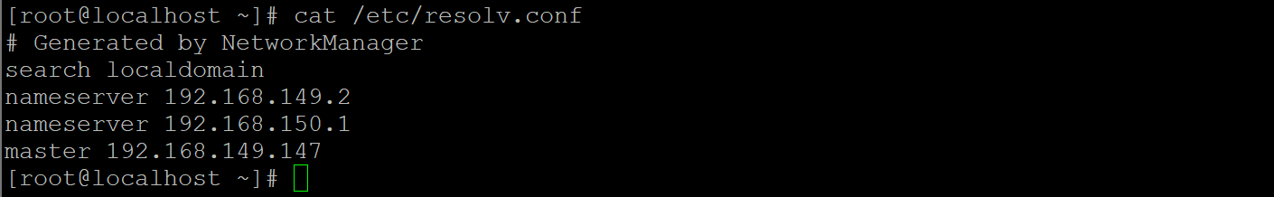

* cp -p /etc/resolv.conf $CHROOT/etc/resolv.conf
* yum -y --installroot=${CHROOT} install ohpc-slurm-client

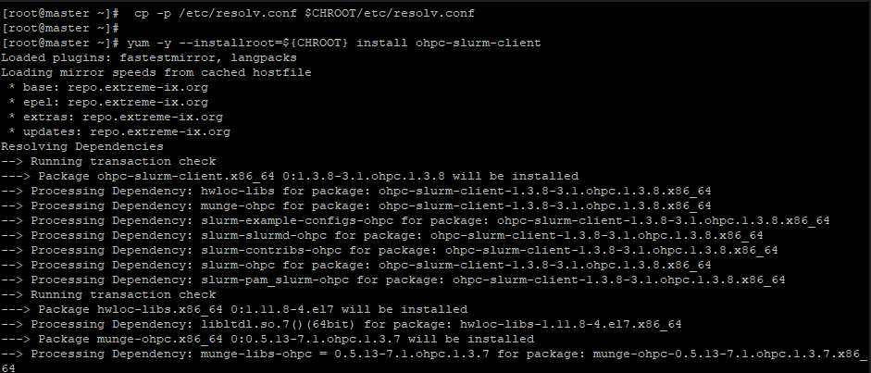

* chroot ${CHROOT} systemctl enable slurmd



* yum -y --installroot=$CHROOT install chrony

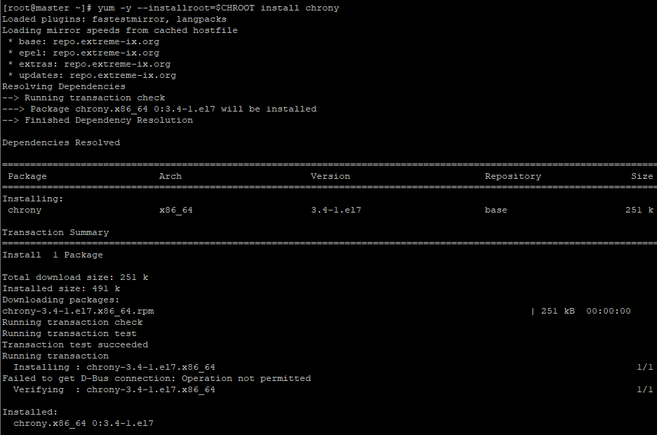

* yum -y --installroot=$CHROOT install kernel lmod-ohpc

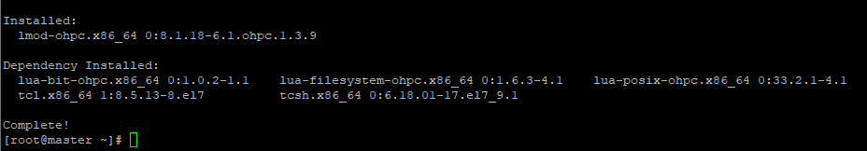

# Initialize warewulf database and ssh\_keys

* wwinit database

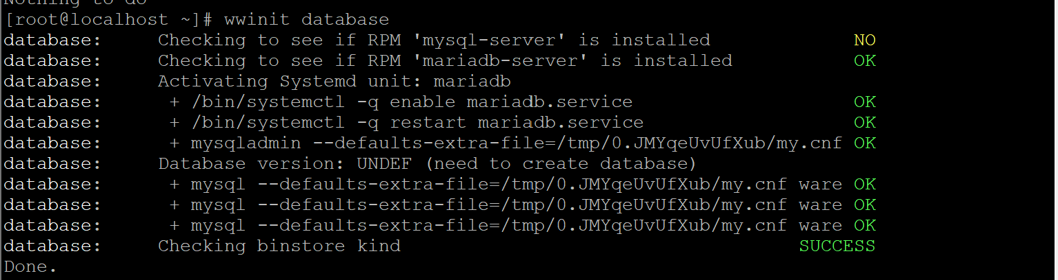

* wwinit ssh\_keys

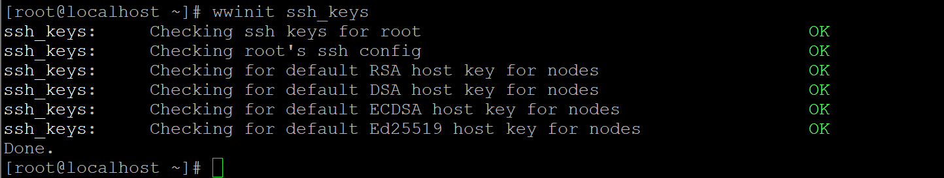

* df -hT | grep -v tmpfs

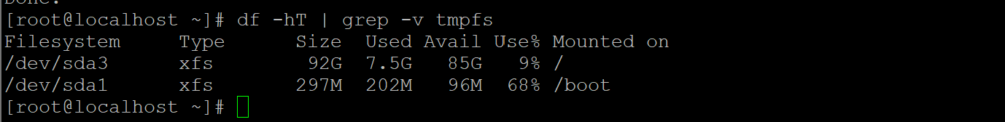

* cat ${CHROOT}/etc/fstab
* echo "master:/home /home nfs nfsvers=3,nodev,nosuid 0 0" >> $CHROOT/etc/fstab
* echo "master:/opt/ohpc/pub /opt/ohpc/pub nfs nfsvers=3,nodev 0 0" >> $CHROOT/etc/fstab
* cat ${CHROOT}/etc/fstab

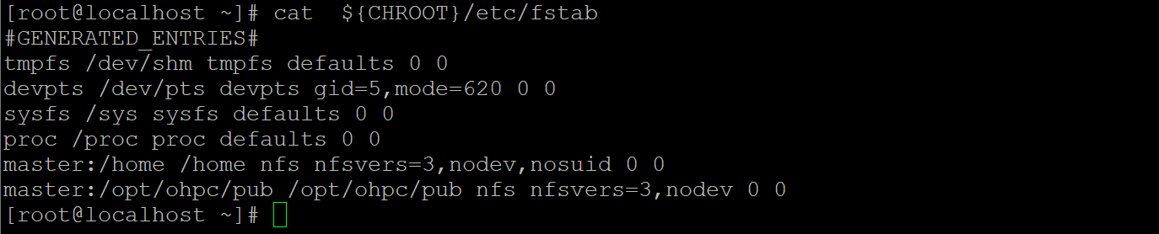

* cat /etc/exports
* echo "/home \*(rw,no\_subtree\_check,fsid=10,no\_root\_squash)" >> /etc/exports
* echo "/opt/ohpc/pub \*(ro,no\_subtree\_check,fsid=11)" >> /etc/exports
* cat /etc/exports



* systemctl start nfs-server
* systemctl status nfs-server

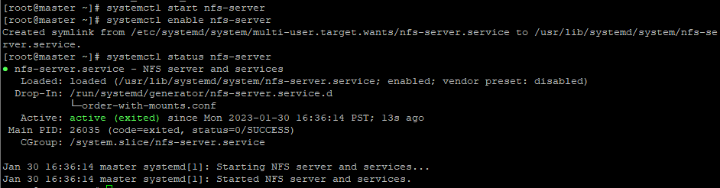

* systemctl enable nfs-server
* exportfs -arv



* chroot $CHROOT systemctl enable chronyd
* echo "server 192.168.149.147 iburst" >> $CHROOT/etc/chrony.conf

**Add Ganglia monitoring**

* yum -y install ohpc-ganglia -> # Install Ganglia meta-package on master

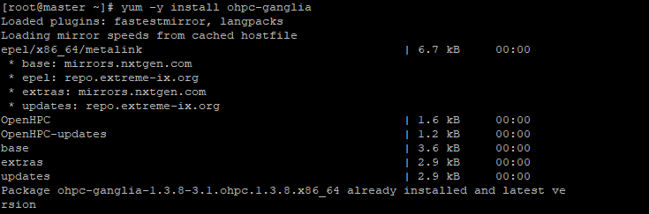

* yum -y --installroot=${CHROOT} install ganglia-gmond-ohpc -> Install Ganglia compute node daemon
* 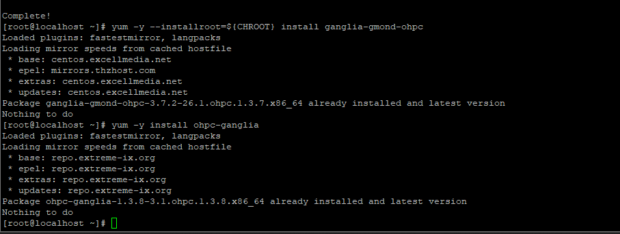
* Use example configuration script to enable unicast receiver on master host
* cp /opt/ohpc/pub/examples/ganglia/gmond.conf /etc/ganglia/gmond.conf -> yes
* grep 'host =' /etc/ganglia/gmond.conf
* sed -i "s/<sms>/master/" /etc/ganglia/gmond.conf
* grep 'host =' /etc/ganglia/gmond.conf

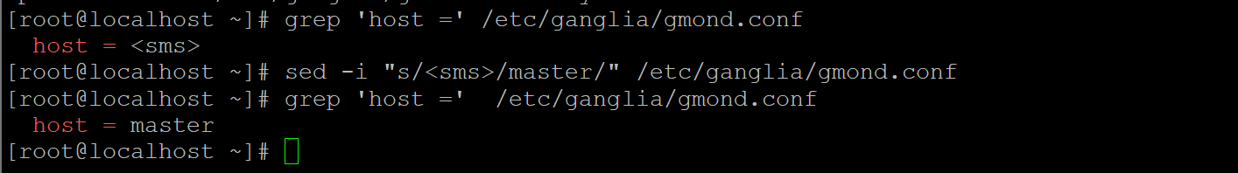

* grep OpenHPC /etc/ganglia/gmond.conf
* sed -i "s/OpenHPC/carbon/" /etc/ganglia/gmond.conf
* grep carbon /etc/ganglia/gmond.conf

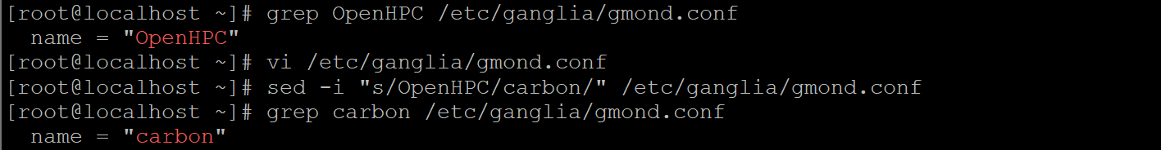

* cp /etc/ganglia/gmond.conf $CHROOT/etc/ganglia/gmond.conf -> yes
* echo "gridname carbon" >> /etc/ganglia/gmetad.conf
* grep gridname /etc/ganglia/gmetad.conf
* echo "systemctl enable gmond
* systemctl enable gmetad
* systemctl start gmond
* systemctl status gmetad

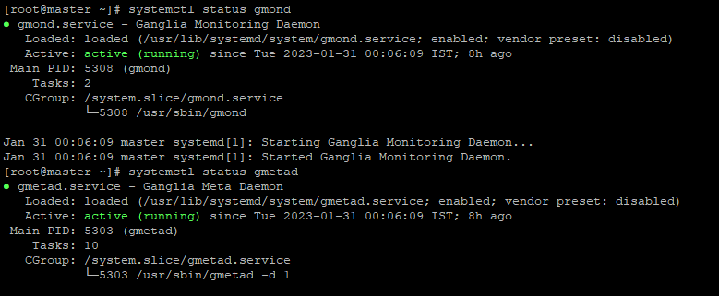

* chroot ${CHROOT} systemctl enable gmond
* " > /tmp/start\_ganglia\_service.sh
* bash /tmp/start\_ganglia\_service.sh

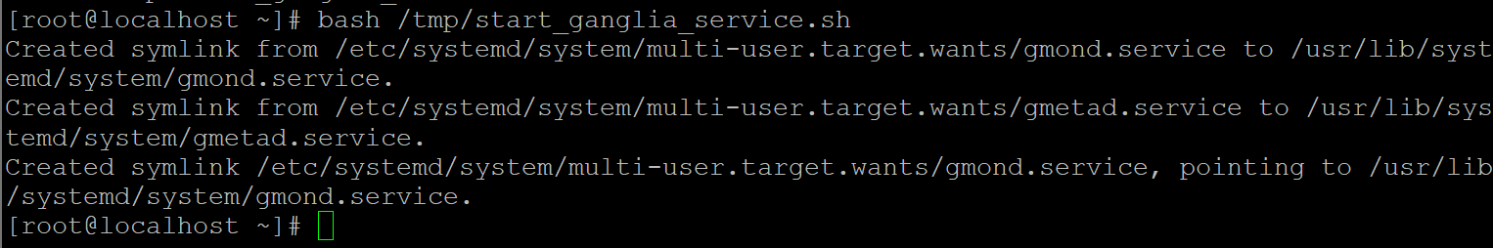

* grep "^date.timezone =" /etc/php.ini
* echo "date.timezone = Asia/Kolkata" >> /etc/php.ini
* grep "^date.timezone =" /etc/php.ini
* systemctl try-restart httpd
* Go to browser : <http://master/ganglia>

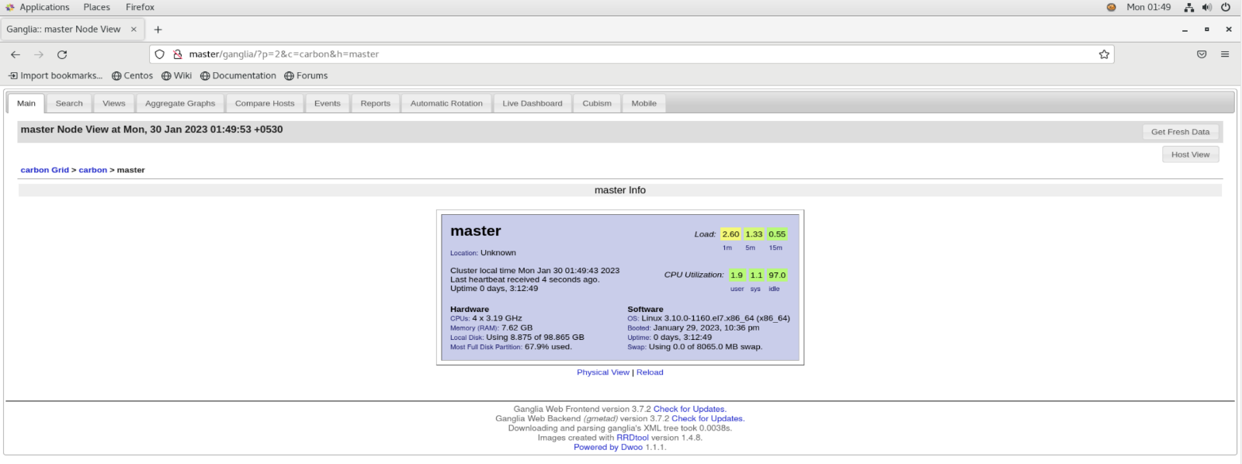

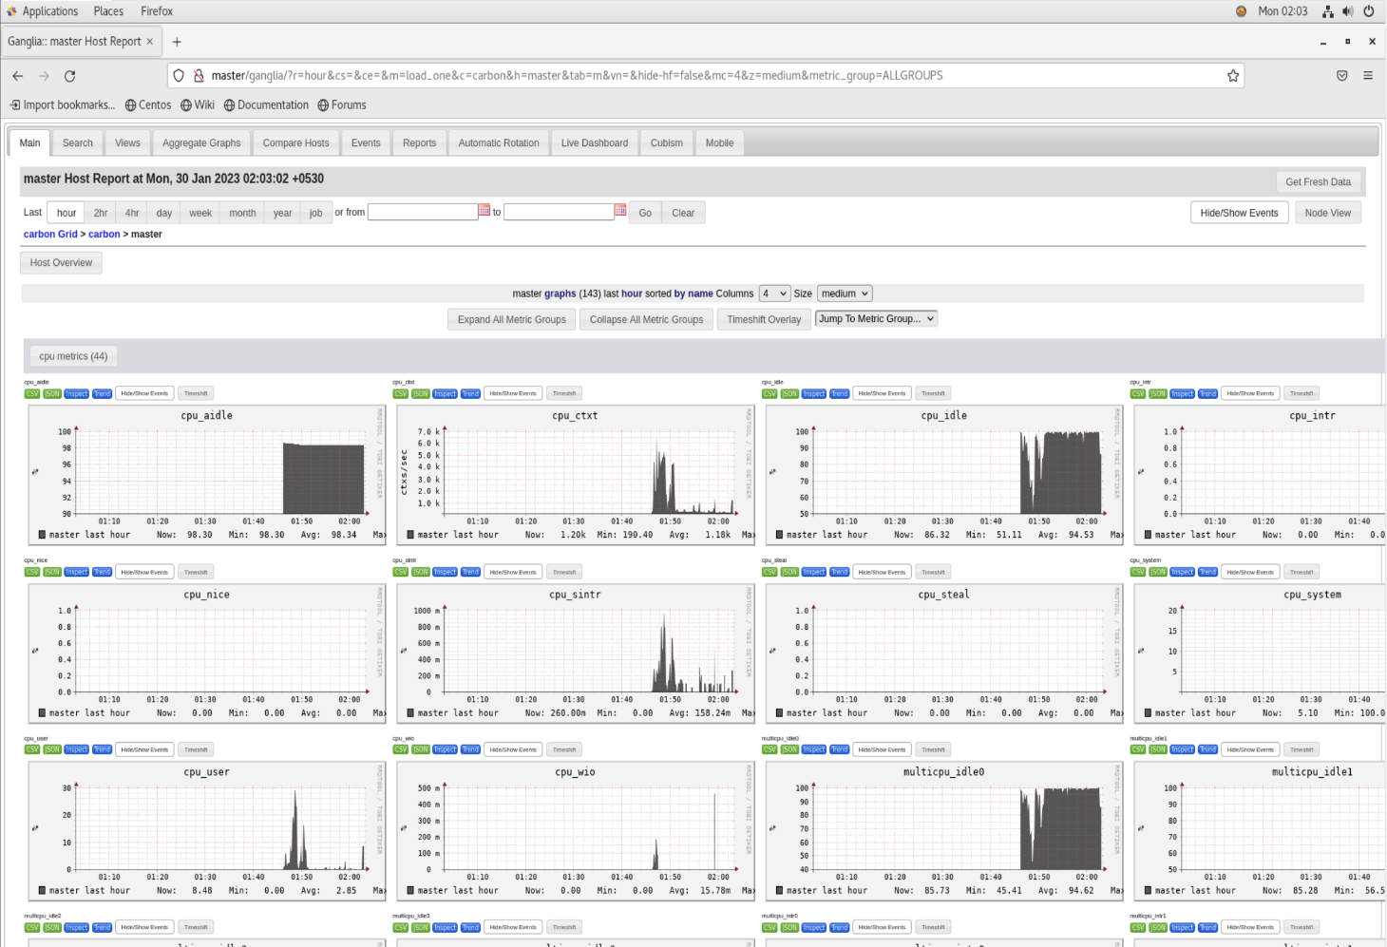

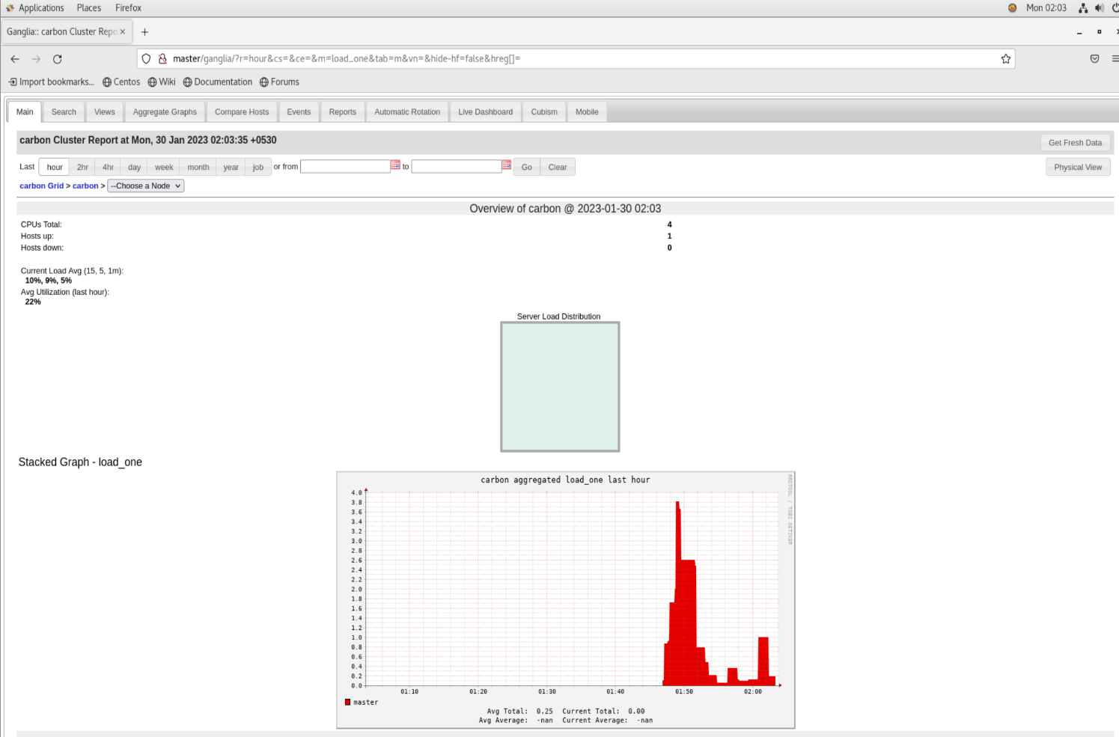Add Nagios moni

**Add Nagios monitoring**

* yum -y install ohpc-nagios -> Install Nagios meta-package on master host

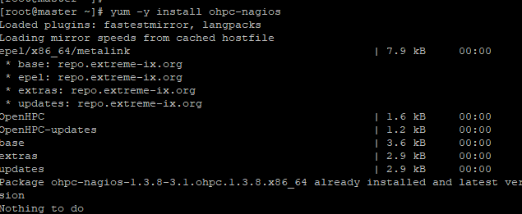

* yum -y --installroot=$CHROOT install nagios-plugins-all-ohpc nrpe-ohpc -> Install plugins into compute node image
* chroot $CHROOT systemctl enable nrpe
* perl -pi -e "s/^allowed\_hosts=/# allowed\_hosts=/" $CHROOT/etc/nagios/nrpe.cfg
* echo "nrpe 5666/tcp # NRPE" >> $CHROOT/etc/services
* echo "nrpe : 192.168.149.147 : ALLOW" >> $CHROOT/etc/hosts.allow
* echo "nrpe : ALL : DENY" >> $CHROOT/etc/hosts.allow
* chroot $CHROOT /usr/sbin/useradd -c "NRPE user for the NRPE service" -d /var/run/nrpe \
* -r -g nrpe -s /sbin/nologin nrpe
* chroot $CHROOT /usr/sbin/groupadd -r nrpe
* Configure remote services to test on compute nodes
* mv /etc/nagios/conf.d/services.cfg.example /etc/nagios/conf.d/services.cfg
* mv /etc/nagios/conf.d/hosts.cfg.example /etc/nagios/conf.d/hosts.cfg
* for ((i=0; i<2; i++)) ; do perl -pi -e "s/HOSTNAME$(($i+1))/${c[$i]}/ || s/HOST$(($i+1))\_IP/${c\_ip[$i]}/" /etc/nagios/conf.d/hosts.cfg; done
* perl -pi -e "s/ \/bin\/mail/ \/usr\/bin\/mailx/g" /etc/nagios/objects/commands.cfg
* perl -pi -e "s/nagios\@localhost/root\@master/" /etc/nagios/objects/contacts.cfg
* echo command[check\_ssh]=/usr/lib64/nagios/plugins/check\_ssh localhost >> $CHROOT/etc/nagios/nrpe.cfg
* htpasswd -bc /etc/nagios/passwd nagiosadmin nagios -> username : nagiosadmin | password: nagios

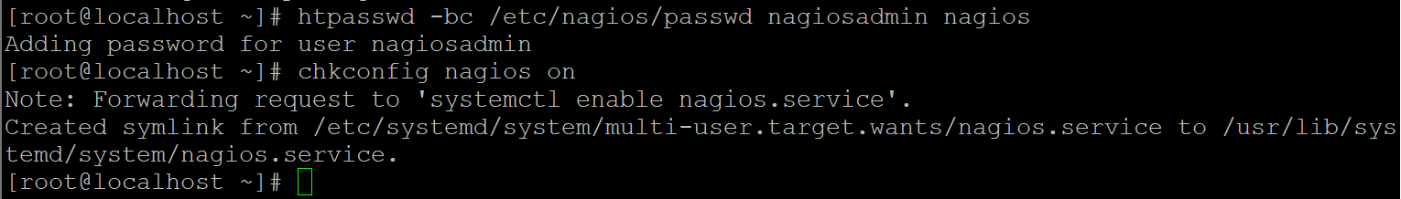

* chkconfig nagios on
* vi /etc/nagios/conf.d/hosts.cfg -> Add clients and hostname
* systemctl start nagios
* systemctl status nagios

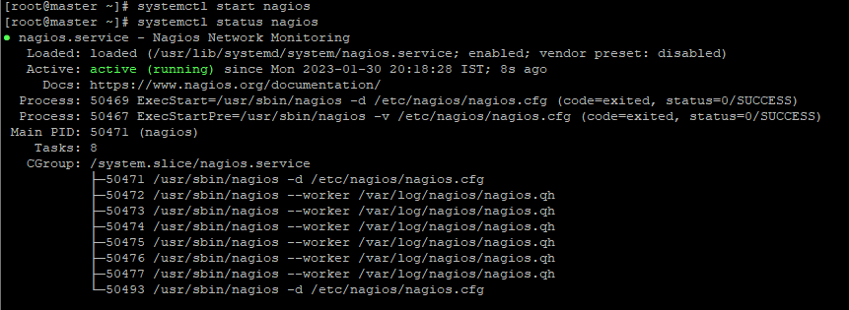

* chmod u+s `which ping`
* Go to browser : http://master/nagios
  + username : nagiosadmin
  + password : nagios

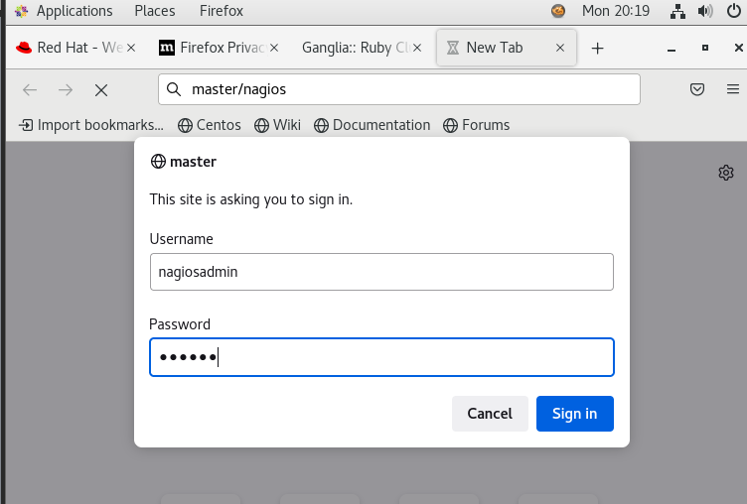

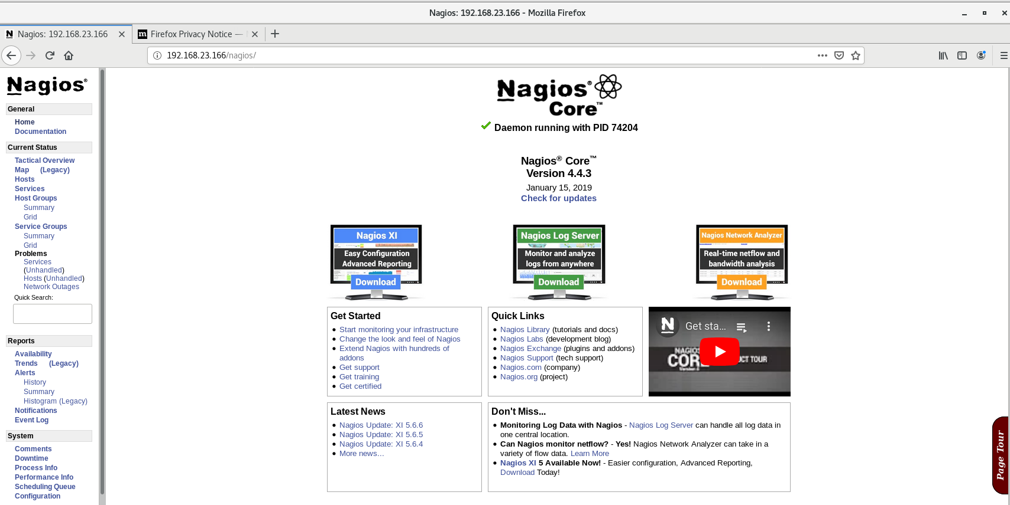

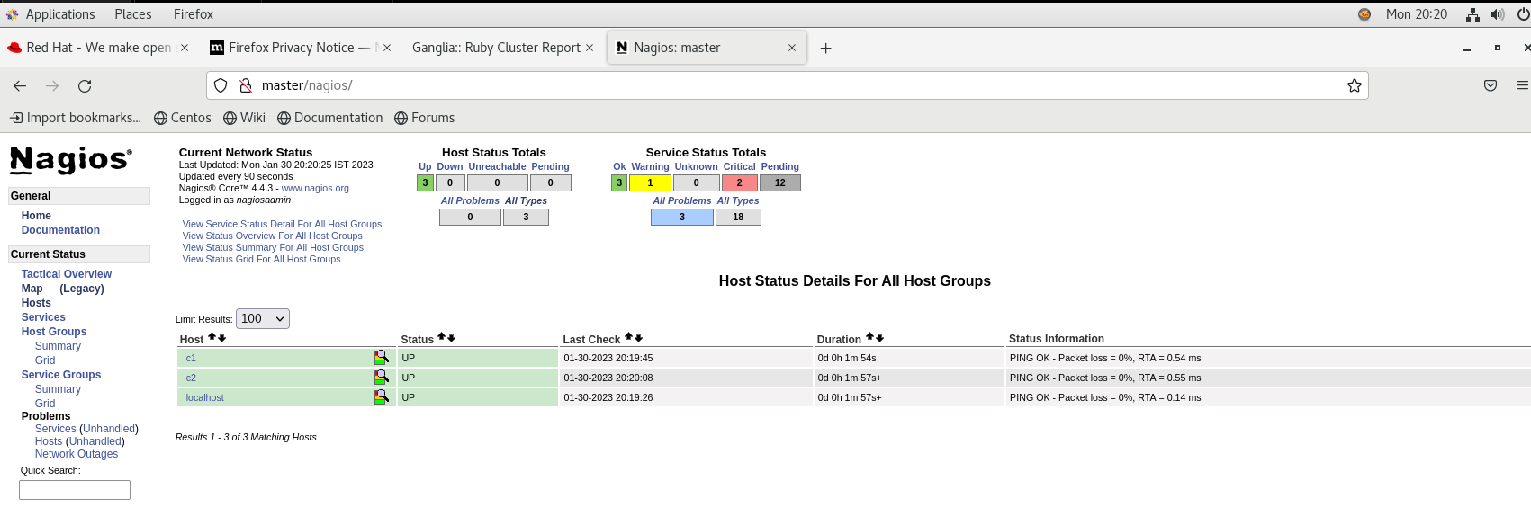

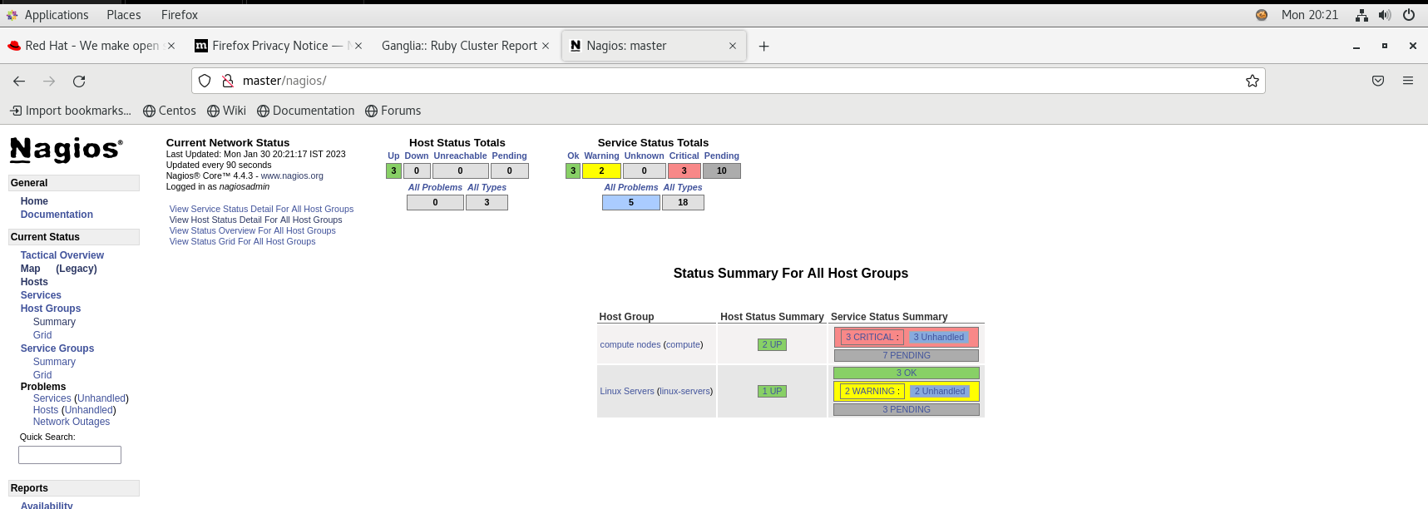

* wwsh file list
* wwsh file import /etc/passwd
* wwsh file import /etc/group
* wwsh file import /etc/shadow
* 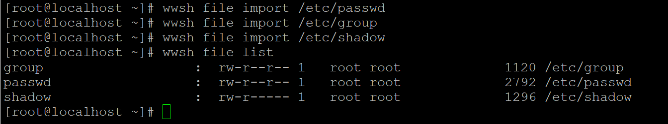wwsh file list
* export WW\_CONF=/etc/warewulf/bootstrap.conf
* echo "drivers += updates/kernel/" >> $WW\_CONF
* echo "modprobe += ahci, nvme" >> $WW\_CONF
* echo "drivers += overlay" >> $WW\_CONF

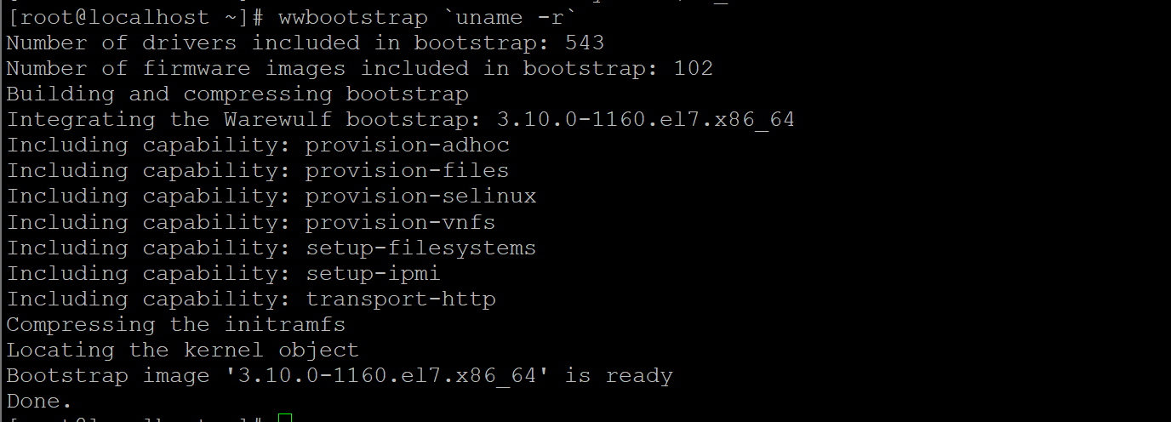

* wwbootstrap `uname -r`
* echo ${CHROOT}
* 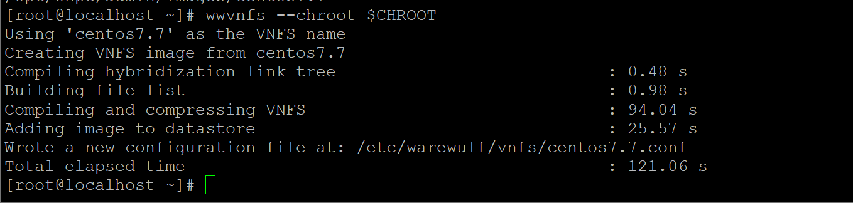wwvnfs --chroot $CHROOT

or

* wwvnfs --chroot /opt/ohpc/admin/images/centos7.7
* wwsh vnfs list



* echo "GATEWAYDEV=ens36" > /tmp/network.wwsh
* wwsh -y file import /tmp/network.wwsh --name network
* wwsh -y file set network --path /etc/sysconfig/network --mode=0644 --uid=0

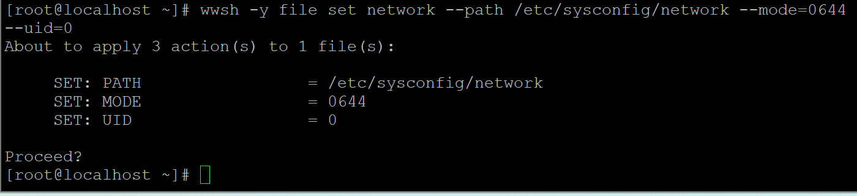

* 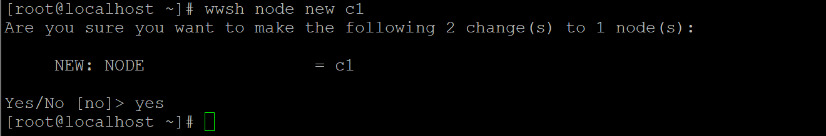wwsh node new c1
* 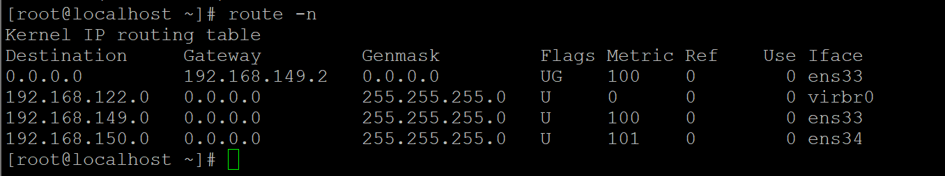route -n
* wwsh node set c1 --netdev ens34 --ipaddr=192.168.150.60 --hwaddr=00:0C:29:EC:16:C2 --netmask=255.255.255.0 --gateway 192.168.149.2
* wwsh node new c2
* wwsh node set c2 --netdev ens34 --ipaddr=192.168.150.61 --hwaddr=00:0c:29:78:09:c8 --netmask=255.255.255.0 --gateway 192.168.149.2
* 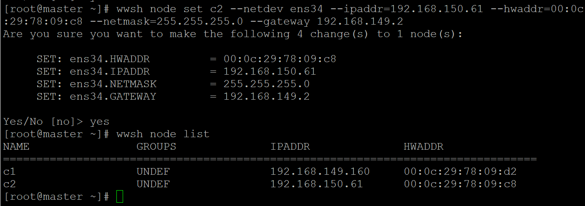wwsh node list
* wwsh -y provision set c1 --vnfs=centos7.7 --bootstrap=`uname -r` --files=dynamic\_hosts,passwd,group,shadow,network
* wwsh -y provision set c2 --vnfs=centos7.7 --bootstrap=`uname -r` --files=dynamic\_hosts,passwd,group,shadow,network
* systemctl restart dhcpd && wwsh pxe update

**HPL-Benchmark**

|  |
| --- |
|  |
|  | * yum install epel-release -y |
|  | * yum install atlas -y |
|  | * rpm -ql atlas |
|  | * wget https://netlib.org/benchmark/hpl/hpl-2.3.tar.gz |
|  | * mv hpl-2.3.tar.gz /root/Downloads/ |
|  | * cd /root/Downloads |
|  | * tar -zxvf hpl-2.3.tar.gz |
|  | * cd hpl-2.3/ |
|  | * cd setup |
|  | * vim Make.Linux\_Intel64 |
|  | * wget https://download.open-mpi.org/release/open-mpi/v4.1/openmpi-4.1.4.tar.gz |
|  | * mv openmpi-4.1.4.tar.gz /root/Downloads/ |
|  | * tar -xvf openmpi-4.1.4.tar.gz |
|  | * cd openmpi-4.1.4/ |
|  | * ./configure --prefix=/opt/openmpi-4.1.4 --enable-orterun-prefix-by-default |
|  | * make -j 8 |
|  | * make install |
|  | * echo $PATH |
|  | * export PATH=/opt/openmpi-4.1.4/bin/:$PATH   C:\Users\dhpcsap\Desktop\warewulf\hpl_benchmarking\exportpath.png |
|  | * mp <Press TAB KEY> |
|  | * export LD\_LIBRARY\_PATH=/opt/openmpi-4.1.4/bin:$LD\_LIBRARY\_PATH |
|  | * echo $LD\_LIBRARY\_PATH   C:\Users\dhpcsap\Desktop\warewulf\hpl_benchmarking\LD_library.png |
|  | * cd ~/Downloads/hpl-2.3/setup |
|  | * cp Make.Linux\_PII\_CBLAS /root/Downloads/hpl-2.3 |
|  | * cd /root/Downloads/hpl-2.3/ |
|  | * rpm -ql atlas |
|  | * vim Make.Linux\_PII\_CBLAS |
|  | >> edit |
|  | # ------------ HPL Directory Structure / HPL library ------------------- |
|  |
|  | TOPdir = /root/Downloads/hpl-2.3 |
|  |
|  | # ------------ Message Passing library (MPI) ---------------------------- |
|  |
|  | MPdir = /opt/openmpi-4.1.4 |
|  |
|  | MPlib = $(MPdir)/lib/libmpi.so |
|  |
|  | # -------------Compilers / linkers - Optimization flags ---------------- |
|  |
|  |
|  | CC = /usr/bin/gcc |
|  |
|  | LINKER = /usr/bin/gcc |
|  |
|  |  |
|  | # ----------Linear Algebra library (BLAS or VSIPL) --------------------- |
|  |
|  |
|  | LAlib = $(LAdir)/libsatlas.so.3 $(LAdir)/libtatlas.so.3 |
|  |  |
|  | >><Escape Key> : wq  C:\Users\dhpcsap\Desktop\warewulf\hpl_benchmarking\MPI nad blas changes.png    C:\Users\dhpcsap\Desktop\warewulf\hpl_benchmarking\openmpi_configuration.png |
|  | * make arch=Linux\_PII\_CBLAS |
|  | * cd /root/Downloads/hpl-2.3/bin/Linux\_PII\_CBLAS/ |
|  | * vi HPL.dat |
|  | * mpirun --allow-run-as-root -np 4 ./xhpl HPL.dat * C:\Users\dhpcsap\Desktop\warewulf\hpl_benchmarking\HPL-benchmark  parameter.png |

